St Mary’s Church
Anywhere
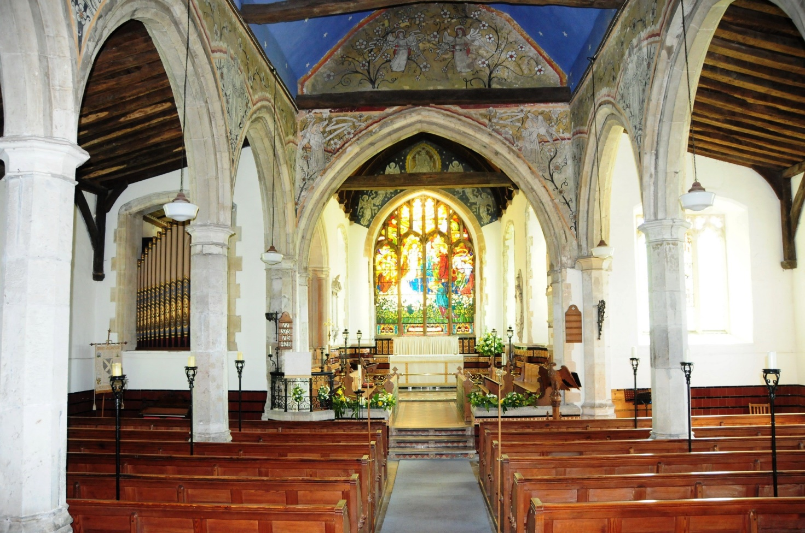

Stewardship Sunday Sunday 15th May at 10.30 am
The service will include a presentation on the future resourcing of our Church.

All Welcome

