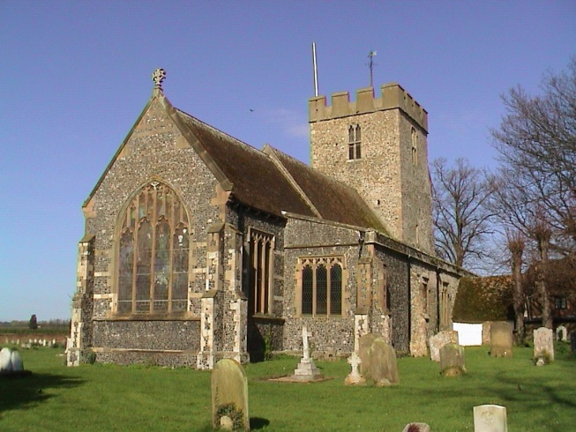

**St Mary’s Church**

**Anywhere**

You are warmly invited to a presentation which will be of great interest to everyone who is part of our parish family. It will take place during the special service on

**Sunday, 24th April at 10.15am**

The Service will include a presentation on the future resourcing of our Church.



**St Mary’s Church**

**Anywhere**

You are warmly invited to a presentation which will be of great interest to everyone who is part of our parish family. It will take place during the special service on

**Sunday, 24th April at 10.15am**

The Service will include a presentation on the future resourcing of our Church.



**St Mary’s Church**

**Anywhere**

You are warmly invited to a presentation which will be of great interest to everyone who is part of our parish family. It will take place during the special service on

**Sunday, 24th April at 10.15am**

The Service will include a presentation on the future resourcing of our Church.



**St Mary’s Church**

**Anywhere**

You are warmly invited to a presentation which will be of great interest to everyone who is part of our parish family. It will take place during the special service on

**Sunday, 24th April at 10.15am**

The Service will include a presentation on the future resourcing of our Church.