**About Poverty and Hope 2025-26**

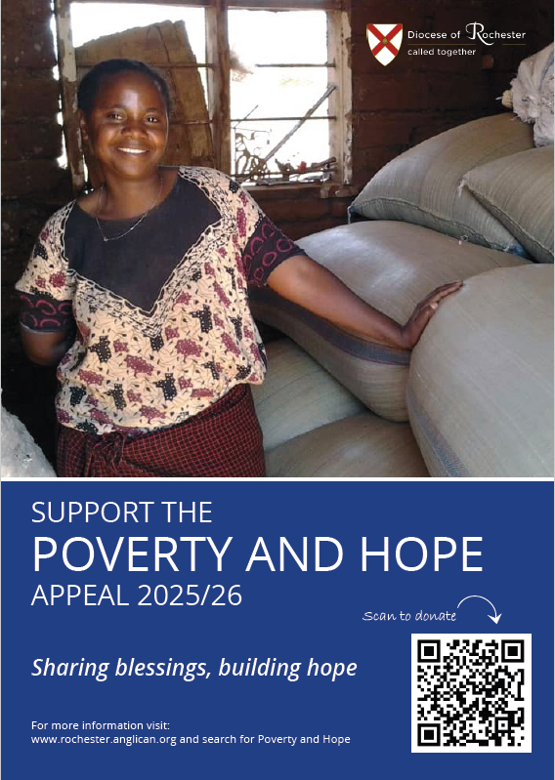Since 1977 Rochester Diocese has, through this annual appeal, helped meet the most basic needs that all of God’s children deserve: a safe place to live; food to eat; and a way to something better. Every year the Appeal has invested modest amounts in life-changing work, sharing God's blessings around the world.

Thanks to the continuing generosity of many parishes and individual donors, last year we were able to distribute £20,000 through our seven partners linking the Rochester Poverty and Hope Appeal with Brazil, the Caribbean, Myanmar, Palestine, Tanzania, and Zimbabwe. Every penny of this has gone to our seven beneficiaries: four international Christian Charities and three African Companion Dioceses. This year our fundraising target is £21,000, which would allow us to distribute £3,000 to each project.

Bishop Simon Burton-Jones, the Bishop of Tonbridge, has this to say in introducing this year’s appeal, which will run through to 30 April 2026:

“*Big nations have cut funding to foreign aid budgets and it means lots of people across the world are now at risk who weren’t this time last year.  Poverty and Hope is a diocesan appeal that acts like an antidote to hang-wringing despair.  It helps to restore self-sufficiency to people who long for this.  The saying ‘every little helps’ is no cliché here, it can save individual lives.  Please give as kindly and generously as you can!”*

You can find out more about all good things happening around the world that the Appeal is helping with, by going to the Rochester Diocesan website at [www.rochester.anglican.org](http://www.rochester.anglican.org) and search for Poverty and Hope.

We know that times are tough right now, so any support you can give is much appreciated. If you are a UK tax payer, please Gift Aid your donation.

You can donate by scanning the QR code in the poster or through a range of options which are given on the website.