Children and Young People (CYP) Fund

Guidelines for Applications and Criteria for Grants

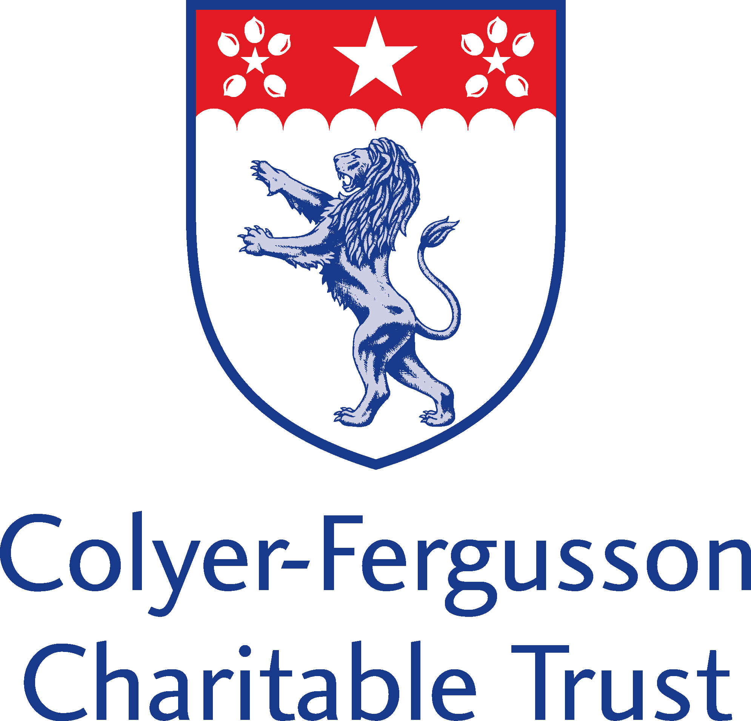

Cheryl Trice, Laura Webster, Sarah Cabella. Diocese Children and Young People Team
Updated July 2021. January 2018

Date: May 2021
These guidelines are to help you apply for the Children and Young People (CYP) Fund. The CYP Fund has a panel of members who will meet quarterly for larger applications £1,500- £5,000, and a fast-track system for applications under £1,500. For projects that might require funding levels beyond the current £5,000 per project limit, where churches work collaboratively within deaneries, the panel will determine an overall budget for a specific area of work or set a limit of £5,000 for each location that is involved in the project (whichever is most appropriate) but with an overall top limit of £10,000 for exceptional circumstances.
The Fund’s overall guidelines are:
The primary aim of the fund is to enable applications to start from a base of which small projects and ministry can build from and be linked to the revised Diocesan Called Together Strategic.
  - Enabling each church to be mission-minded
  - Helping children, young people, and adults live out everyday faith in Jesus
  - Supporting loving service in local communities
  - Encouraging, and responding to, the prophetic voice of justice and peace
  - Protecting creation’s life for future generations
This can also include existing projects and groups that need additional resourcing; however, the fund is unable to reimburse for monies already spent or for equipment already purchased. There will be a strong emphasis to reach the local and immediate community with a Christian ethos behind the work of the project, particularly within areas of deprivation, that they demonstrate the love of Christ and following Jesus’ example of enabling people to be complete and have an identity in Christ. The projects must be local and not in competition with existing work but demonstrating a capability to co-operate effectively with a clear intent to improve the lives and opportunities of children and young people wherever they are on their faith journey. The applicants must show a desire to think beyond programmes and activities to a more systematic approach, integrating the wider community, understanding the characteristics and ethos of the community, alongside being realistic about objectives, timeframes and scope for sustainability.

Project applications will need to demonstrate, in line with revised “Called Together Framework”, that they provide –
- Specific opportunities / projects to enhance and enrich the lives of local children and young people
- A strong evidenced commitment from the applicants to the projects by providing support, volunteers and an understanding of the community it serves (this will need to be outlined on the application form)
- Combining vision with reality and future developments
- Intentional spiritual discipleship and faith building through the objectives / aims, therefore enabling people to be Christ centred and the complete person Christ intended them to be
- Evidence of the parish(es) consideration of their local communities and the impact / difference that enables the project to grow, enrich and resource the community
- Does the project cover and / or include social action, informed education, improving community cohesion?
- Enabling learning or greater earning capability
- Deal with issues associated with low income – including self-esteem, self-worth, motivation, identity and poor mental health
- Provide environments where relationship, trust and commitment to the local community becomes embedded into the Churches ministry and mission
- Create a culture of change, improving social inclusion and self-belief / worth for all
All Applications must include -
- an explanation of the project and how it is expected to develop
- a realistic plan of action and resourcing
- a process for monitoring progress and evaluating outcomes against the objectives
- a clear budget with accurate costings, for both income and costs – use the CYP Budget Sheet
- a plan for funding the shortfall between the amount applied for and the amount needed
- an assessment of the major risks in carrying out the project
- plans for the long-term viability of the project once the grant ends. The project must demonstrate sustainability beyond the CYP funding
Key issues
- The CYP Fund is for direct delivery towards children and young people’s ministry, but salaries for employing a worker are outside of the scope of the fund. However, resourcing a specialist for a specific task or activity area of the project is permitted.
- The grant cannot be used for commercial enterprises.
- Resourcing a room or equipping it for a new work would be permitted but buildings of themselves are outside the scope of the fund
- The fund aims to nurture the development of new, existing and extended work in parallel with existing ministries.
Proposed Application Process
Applications will be welcomed from parishes and deaneries and in conjunction with partnering organisations working collaboratively, known to the Diocese of Rochester.
Applications will only be accepted on the application form which can be found at Diocese of Rochester | Children and Young People (CYP) Fund (anglican.org) or by contacting sarah.cabella@rochester.anglican.org. All applications must be returned to Sarah Cabella – sarah.cabella@rochester.anglican.org, preferably by email, or by post to Diocesan Office, St Nicholas Church, Boley Hill, Rochester, Kent. ME1 1SL.
An application will be assessed as to the level of grant needed from the limited financial resources of the fund and will be examined against the criteria above.
Once a grant has been awarded by either the fast-track or the full CYP Fund panel, the Grant Organiser will be notified within two weeks of the panel decision, with monitoring procedures set in motion. These will include –
A six week initial progress report, via a telephone call.
A six month monitoring visit and / or a recorded evaluation of the outcomes against the objectives. (Dependant on the project and in negotiation with the CYP Team).
If an application for a grant is unsuccessful, the panel will provide an explanation. Revised applications will be considered at the next deadline.
If there are any surplus funds left over from the grant awarded, these will need to be returned or negotiated with the funds panel, to fund similar projects within the near future of the original application.
Applicants will be able to re-apply to the CYP fund if they have previously been awarded a grant and it has proven successful.
Project update:
As stated above, but –
A six week initial progress report, via a telephone call.
A six month monitoring visit and / or a recorded evaluation of the outcomes against the objectives. (Dependant on the project and in negotiation with the CYP Team).
On completion of the project a fuller evaluation will be required. This is to include photos, videos and write-up reports that can be used on Diocesan platforms to fulfil the implementation of the “Called Together” Framework.

Application Deadlines for 2022

APPLICATION DEADLINE | PANEL MEETING
11th March | 23rd March
1st July | 6th July
16th September | 27th September
25th November | 6th December

Fast Track Applications can be submitted at any stage of the year

