How to Welcome Under 5’s in your Church

August 2022
Introduction
These spaces have become a more common sight in our churches. They are a way to demonstrate to families that they are welcome in your church family. So please make it bright and cheerful avoiding anything tatty or broken – be gentle but firm with kind-hearted donors and ensure what you offer families reflects the value you place on them. They do not need to be costly; charity shops often have toys that would work or ask members of the congregation to make toys that would fit.
Position
Please consider the best place for the space. Security is important for parents so away from outside doors is essential. Can the children see what is happening at the front? do their families feel included or side-lined? It is also important for these families to feel welcomed and secure in church. Parents are very conscious of the noise their children make and will be concerned about disturbing the congregation so anything you can say from the front to put them at their ease the better. It also helps the rest of your congregation understand the need for welcome and sympathy. If possible, put a welcoming statement on pew-sheets, websites and in the area itself. We have some examples to share; do ask.
Volunteers
Consider having a small team of volunteers who take it in turns to sit in the area with the families. It will make it feel less intimidating for a family to sit there as well as help those who are unfamiliar with your church to understand the service. It does not need to be young parents – it’s a role well suited to grand-parents. They can lay out the area before the service and leave it tidy for the next week as well as help distracting the more fractious child, befriending the parents and helping them navigate the service.
Contents
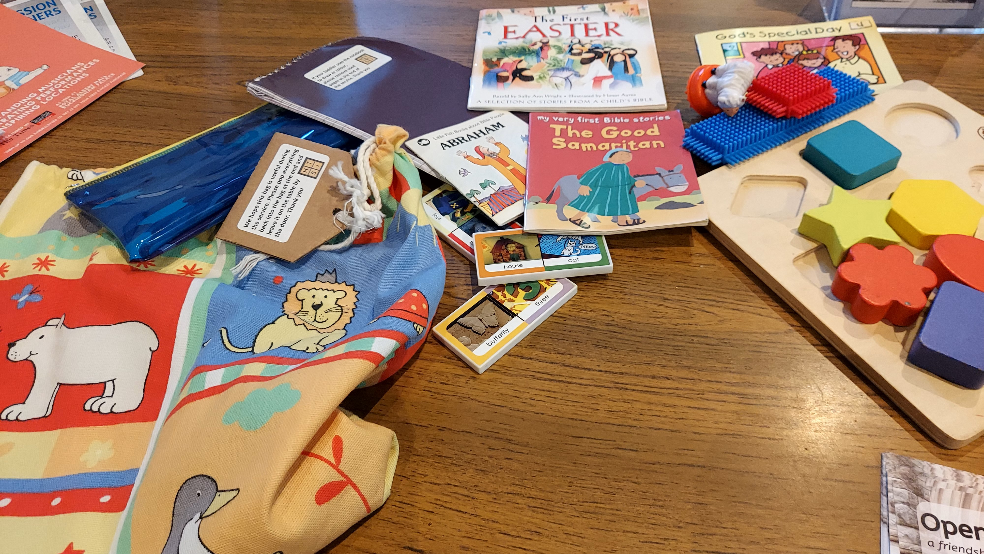
As you decide what to include be imaginative, colouring has it’s place but so does plain paper and open-ended activities. Try to make the colouring sheet connect with the service or the season. Make sure the pens work and the pencils are sharp. Do consider that some parents would rather sit in the congregation with their child so find ways the resources can be ‘taken away’. Canvas bags that parents could put a few toys in would work. Here is an example you could adapt.
Story bags or baskets work too. Offer clipboards for those that would rather colour. Older children may want to sit with their families, especially those visiting who do not have the confidence to access your children’s ministry, so a few puzzles, wordsearches, older books would also be helpful. As you consider what toys to include do consider quality – cheap toys break easily and need replacing more often. Try to avoid toys that have sound built-in (toys without batteries frustrate children) but any toy can be noisy – children are very inventive!
Consider the children who will use this space; do the toys reflect them? Ensure there are books at least that reflect different families; consider race, disability, blended families etc. And think about storage; an area looks more appealing if it is tidy (at least to start) with a labelled place for everything. Ease of cleaning is another consideration. As the area is used more it will become clear what works and what is less popular.

Practical ideas
Have a bin nearby – children are messy and parents like to clear up! And a box of tissues nearby will be a popular touch. Do you offer a baby-change area? If you do consider leaving a small box of changing resources. Wipes, bags and nappies. Most parents come prepared but occasionally that is not enough.
It is important to consider some children have additional needs, some of which may be obvious, other needs less so. Accessibility is clearly needed but often the best approach is to ask parents if there is anything else that would help their child feel welcome.
We have information on those organisations who can help with that in more detail.
It’s easy to make the children’s corner just an ordinary secular play-space, but with a slight change in mindset, this can actually be turned into an opportunity for developing children’s spirituality.
Examples
Here are some images of sacred spaces for children in a variety of churches.
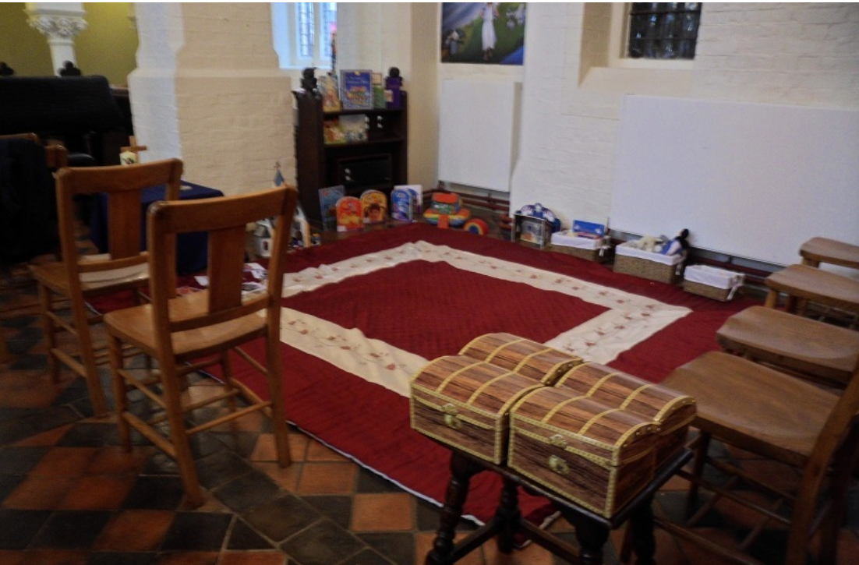
This is the “Pray and Play” space at St. George’s Church, Campden Hill, London. Each basket is themed with Baptism, Christmas, and Easter, as well as a Noah’s Ark with animals, a book corner, and a small toy altar with liturgical items and a toy church.
The focus is both on the Christian story and the worship. If you would like some ideas of contents for story/worship boxes, please ask.
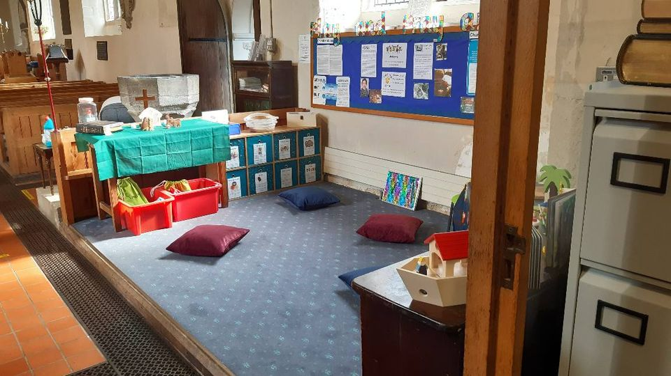
You can make the colour of the cloth on the altar match the main church if that is part of your tradition. You can also add extra items for specific festivals. The treasure boxes contain items like the Spiritual Child Network’s liturgy boxes.

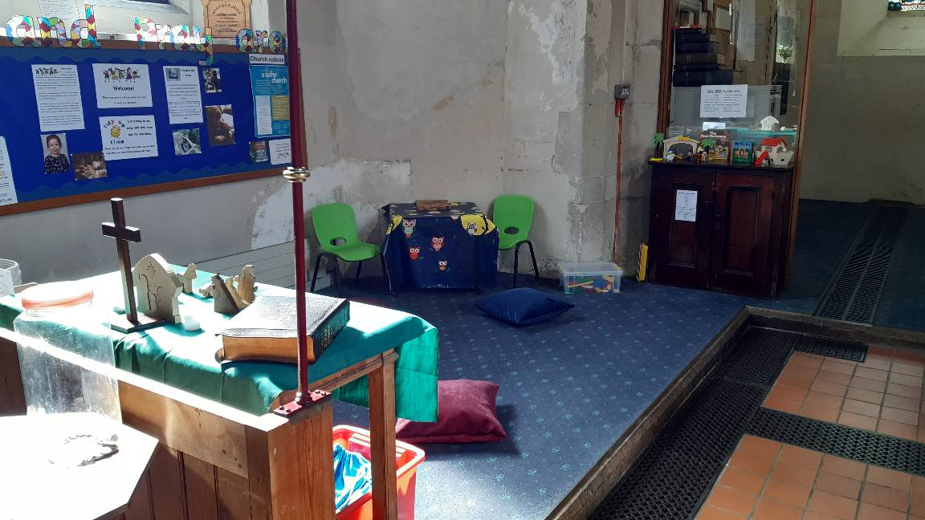
These images are from Downe Parish Church where they used the CYP fund to set up a Pray and Play area. They used a very small space in a traditional church now filled with opportunities to play with Bible stories as well as other resources. The local school made up one of the story bags. There are boxes for the festivals too.

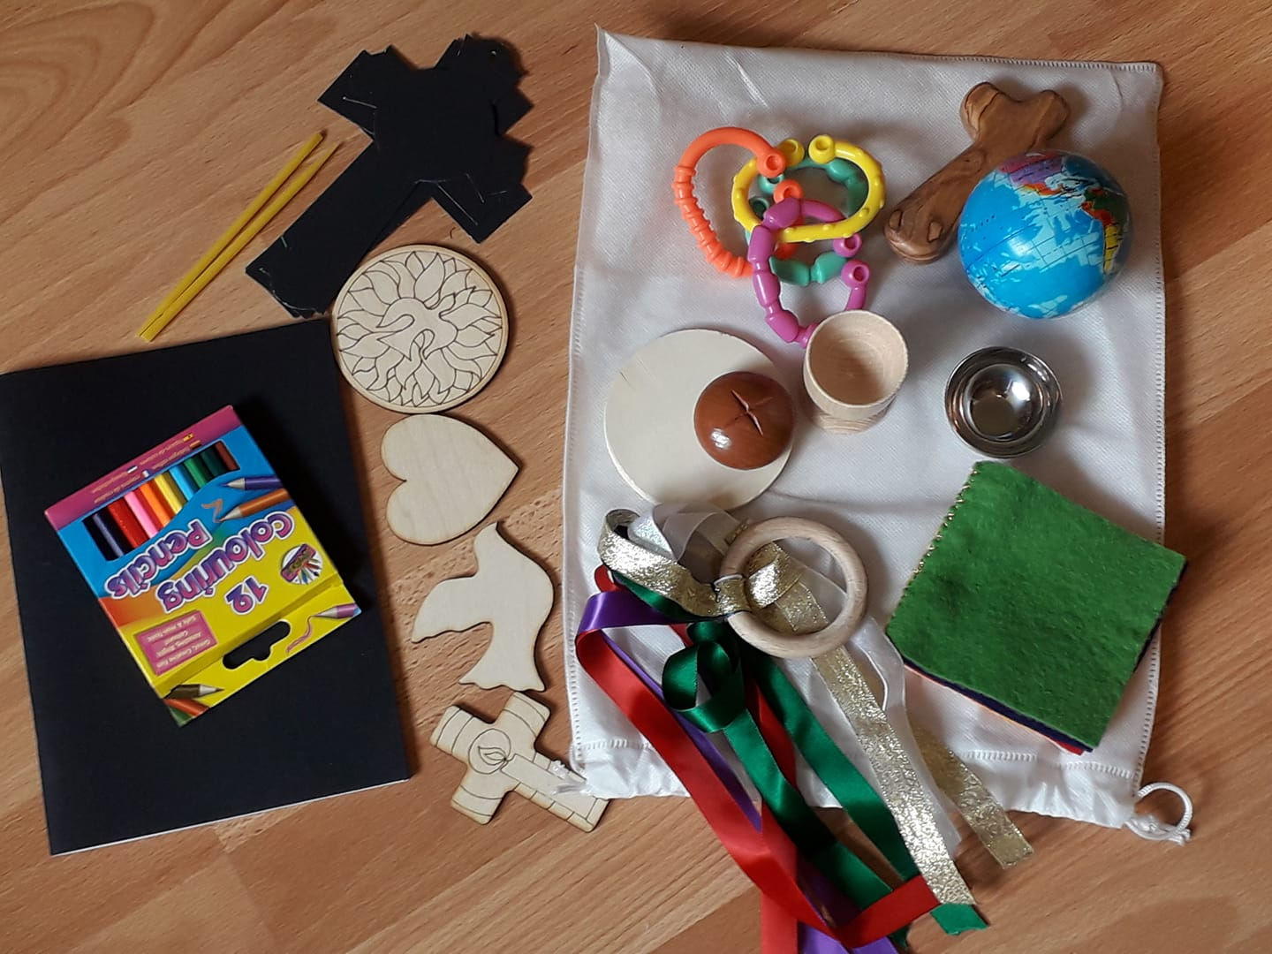
Or make up Liturgy Bags : these include:
Linking rings of some kind :gathering together, Holding Cross Confession, Liturgical colours felt book, liturgical coloured ribbon ring home made curtain ring and sewn on ribbons 14"" max! Wooden Coaster & egg cup for Chalice and Paten, small spice bowl font, world foam ball for prayers, drawing book crayons scratch art and other faith based wooden shapes for creative use.

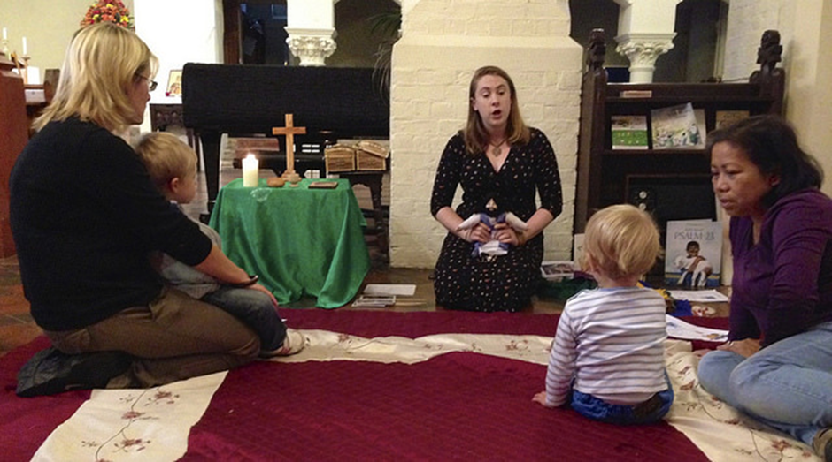

The space could be used as a space for a Toddler Church or for the worship space for Messy Church.

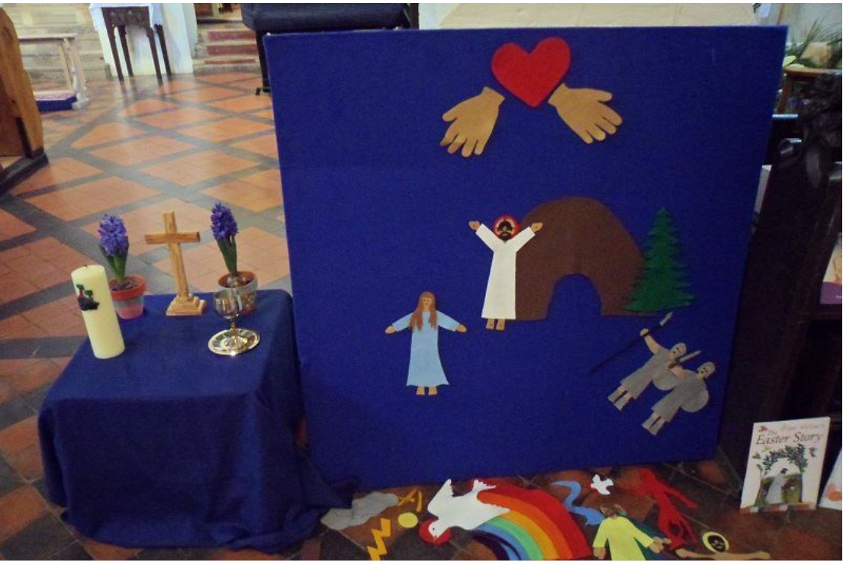

A board like this can be made inexpensively and the felt characters added slowly. Much is interchangeable with Bible stories – just make sure you keep certain pieces together – plastic wallets in a folder would work. Beulahland at the Mustard Seed Kids website has ready made sets as well as advice of how to make the board.

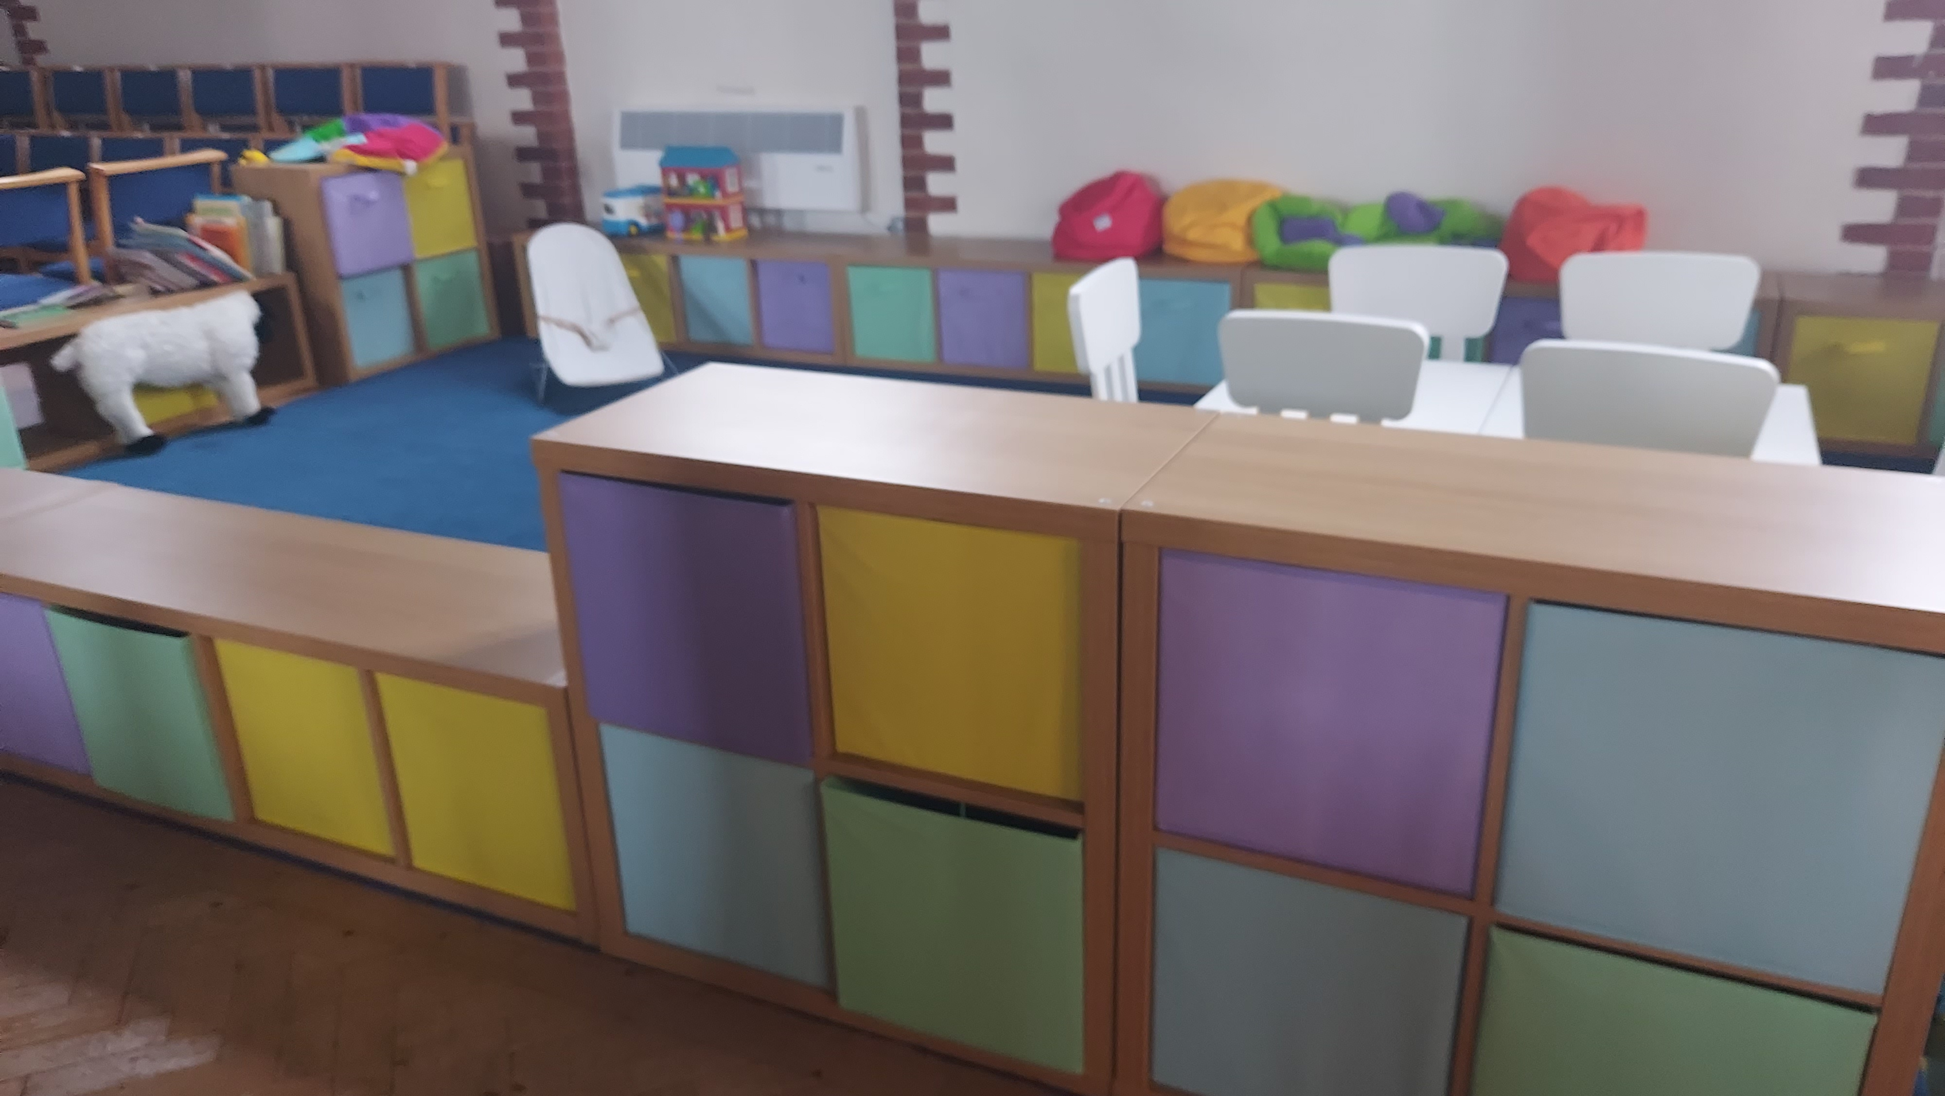
This area is bright, clear and sends a ‘we welcome children’ signal as soon as you walk in to the church.
The furniture is all moveable so can be adapted to service needs. The boxes could be labelled and the tops to these can be sat on offering seating for parents.

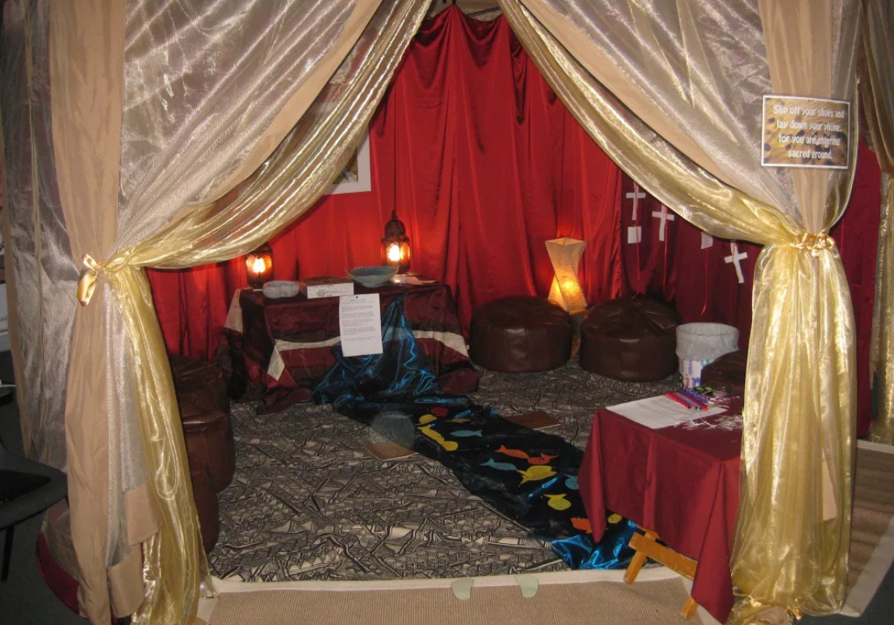
This one is slightly different it was used as a “Meditation Tent” in a Holiday Club in Nottinghamshire, and therefore can be more of a roped-off space than one used during corporate worship. This allows for great creativity in terms of lighting and the overall atmosphere of the space. Consider a sign reading, “slip off your shoes and lay down your phone, for you are entering sacred ground.” This one would work well for older children and teens. This could be used during 24x7 prayer events or as a staple part of your children’s or youth ministry. If it will only work at certain events consider offering it to your local school or other churches as a reflection space.
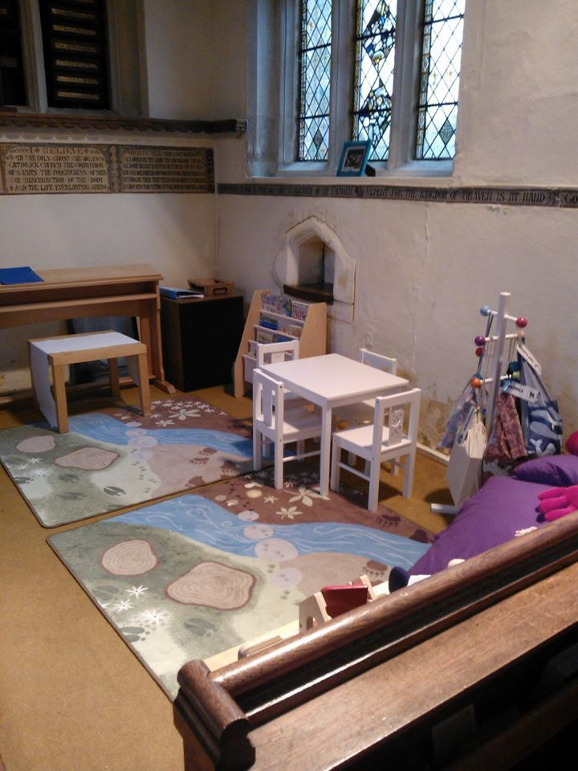
The table and chairs here provide space for creative work – make sure you provide materials allowing for open-ended creation and not just colouring sheets. The coat hanger features Bible-based story sacks, with storybooks and toys connected to that story. There is an area with, cushions and other toys to play with. The mat sadly is not now available new but it may be on Ebay.

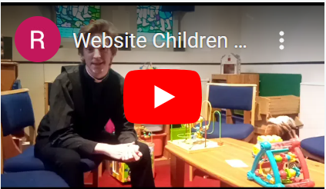
This church has used a small space to great effect and the video on their website makes it clear how welcoming they are to children.
https://www.stjohnsbexley.org.uk/worship/childrens-ministry/
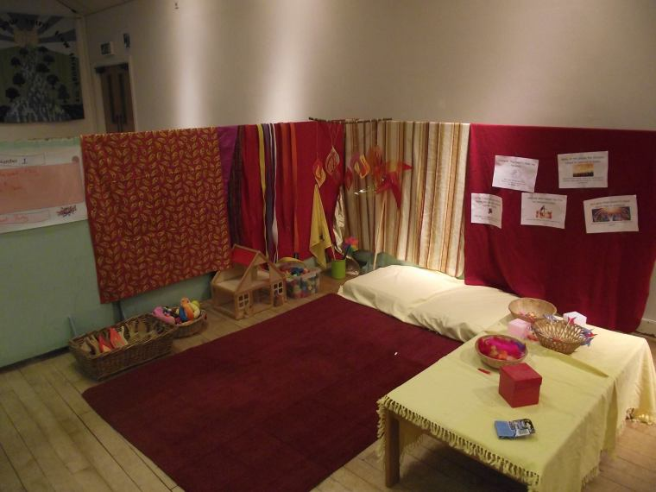
This was a special installation for Pentecost. Its creator says, “in MY head the doll’s house was meant to be the upper room in this case, but with children it could become anything in their heads! It’s also been house-with-stable for Christmas, wedding feast house for water into wine, anyone’s house when we talked about hospitality and sharing things in common…quite versatile!”

For more ideas on children’s area, see the Spiritual Child Network’s page on them.
With thanks to St Albans Diocese and Carolynn Pritchard

